We have generated three reports after our final ERD diagram, provided in Milestone 2. We noticed that our field Asset_ID in the asset table was not a uniform number. We also noticed that assigning a set value for the field Asset_Value did not make sense, as every asset is worth a different amount. Therefore, we have now moved Asset_ID and Asset_Value to the transactions table.

With those changes to help answer the following questions:

1. How many clients have been added for each of the past six months?
2. What is the average amount of assets (in currency) for the entire client list?
3. How many clients have a high number (more than ten a month) of transactions?

The first report we have scripted is to calculate the average amount, in currency, of assets Willson Financial manages. We were able to calculate this with the query “SELECT AVG (asset_value) FROM transactions"

**Output for report #1:**

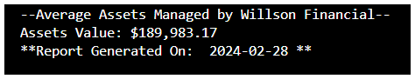

The second report scripted was to help answer the question, “How many clients have a high number (more than ten a month) of transactions?” Since Willson Financial does not have enough client transactions for this exact question just yet, we decided to run a report to display which clients have ten or more transactions in total with the company.

**Output for report #2:**

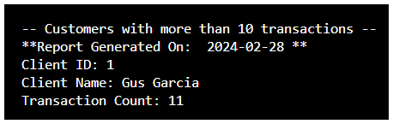

Another question Willson Financial needed answered was, “How many clients have been added for each of the past six months?” We ran a report to see how many new clients were added in the past six months.

**Output for report #3:**

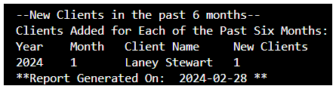

This report output shows Willson Financial's year, month, and client name, which have been added within the last six months. In the end, we have a total count as “New Clients” to calculate how many clients were newly added in total. In the past six months, only one new client has been added in January 2024.